<https://docs.atlassian.com/software/jira/docs/api/REST/7.6.1/#api/2/issue-updateComment>

ALWAYS NOTE THAT NEW SESSION ID SHOULD BE GIVEN AS COOKIE FOR ALL OPERATIONS

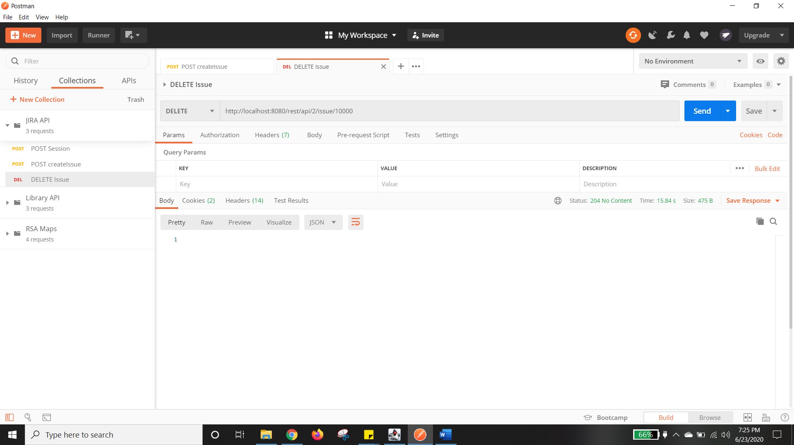

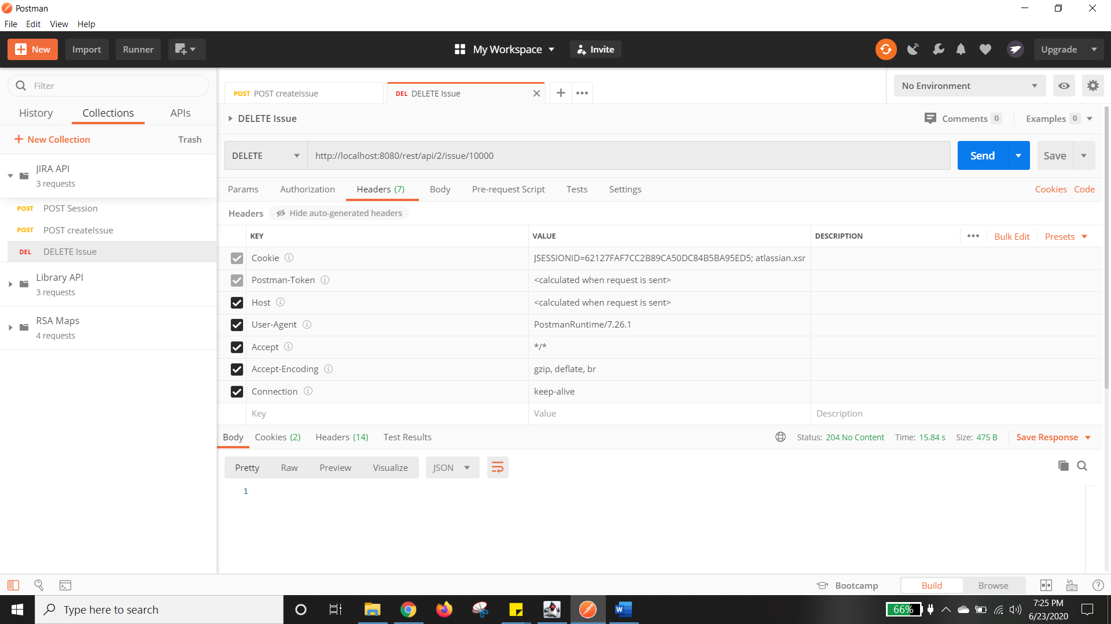

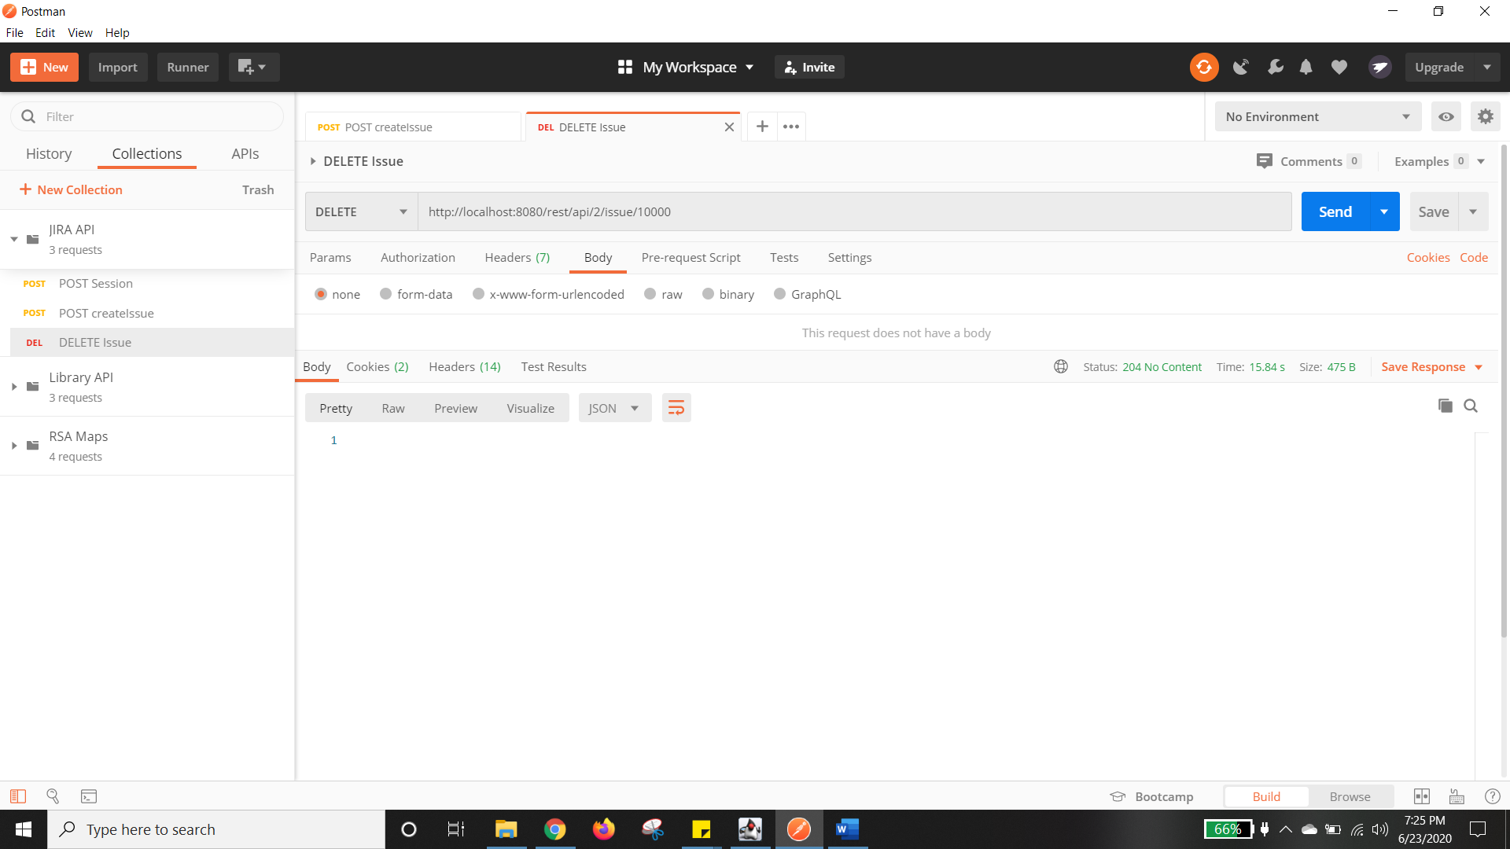

STATUS 204 no content means it is deleted

